**Lesson 4:**

**⇒** var and var-**hoisting** has been removed from solidity version 5.0

⇒ Solidity is a static type language

**Type Conversion:**

1. Implicit Type Casting
2. Explicit Type Casting

**Implicit Conversion:**

⇒ mean storing a single data type to a larger data type (it will be automatic there is no need for an operator)

e.g.

uint8 a = 12; // range from 0-255

uint16 b = a; // range from 0-65535

⇒ Its type safe conversion

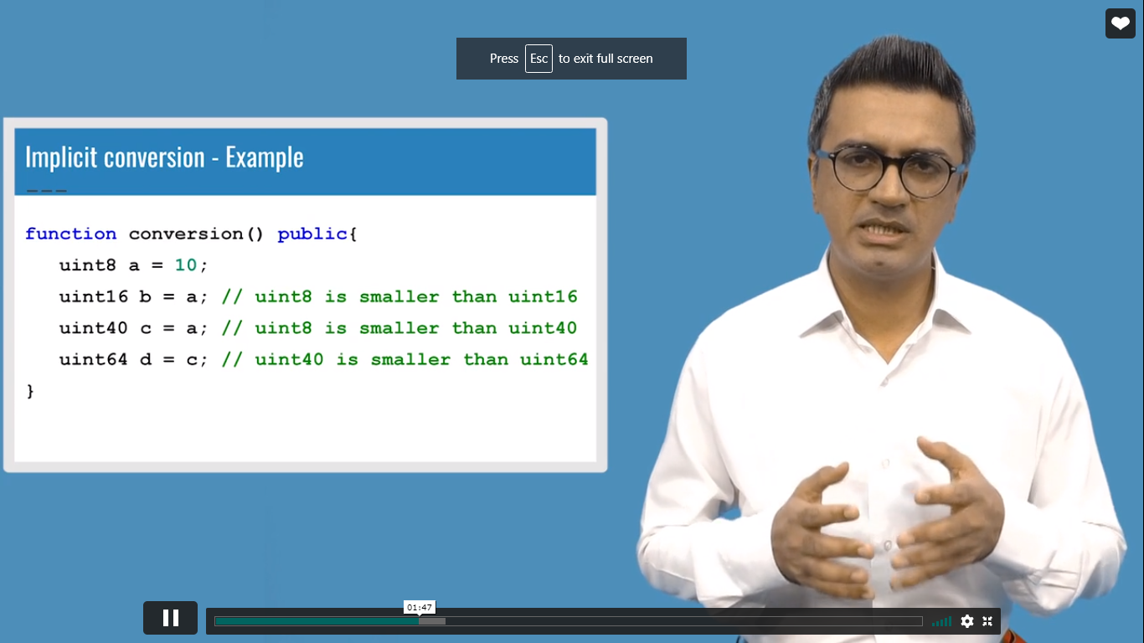

**Explicit Conversion:**

**⇒** storing larger data type to small data type (forcefully)

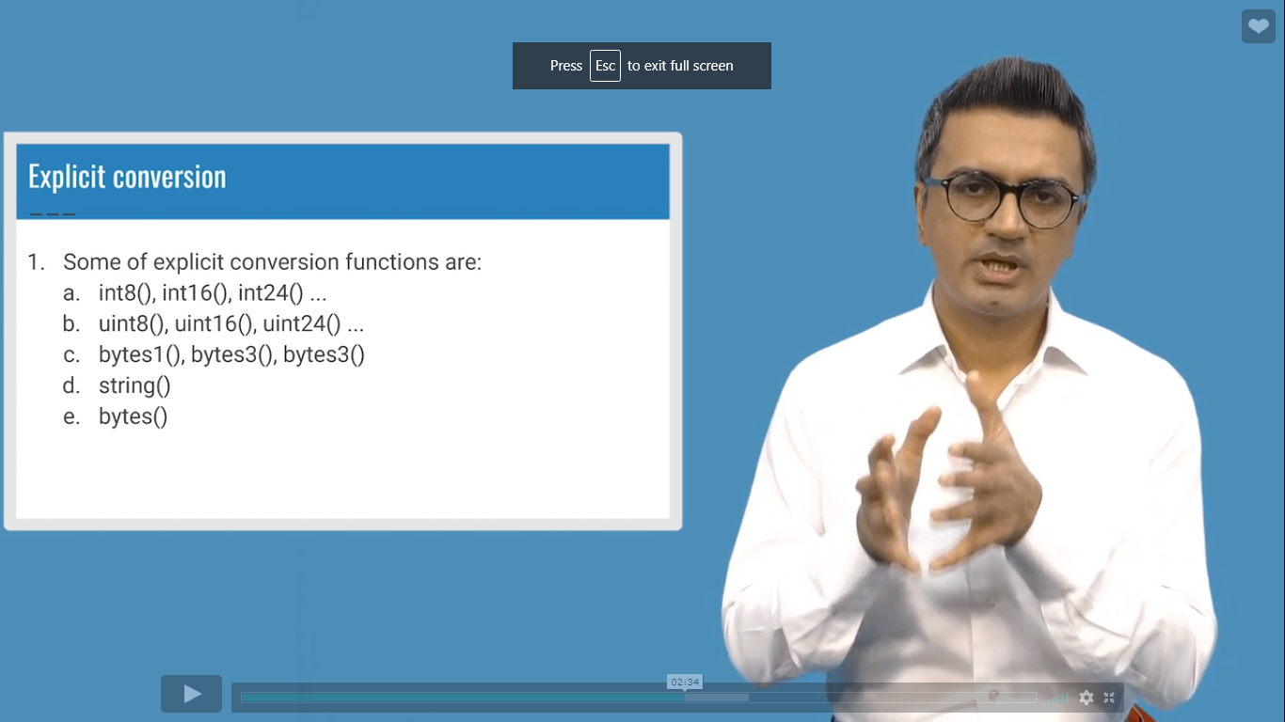

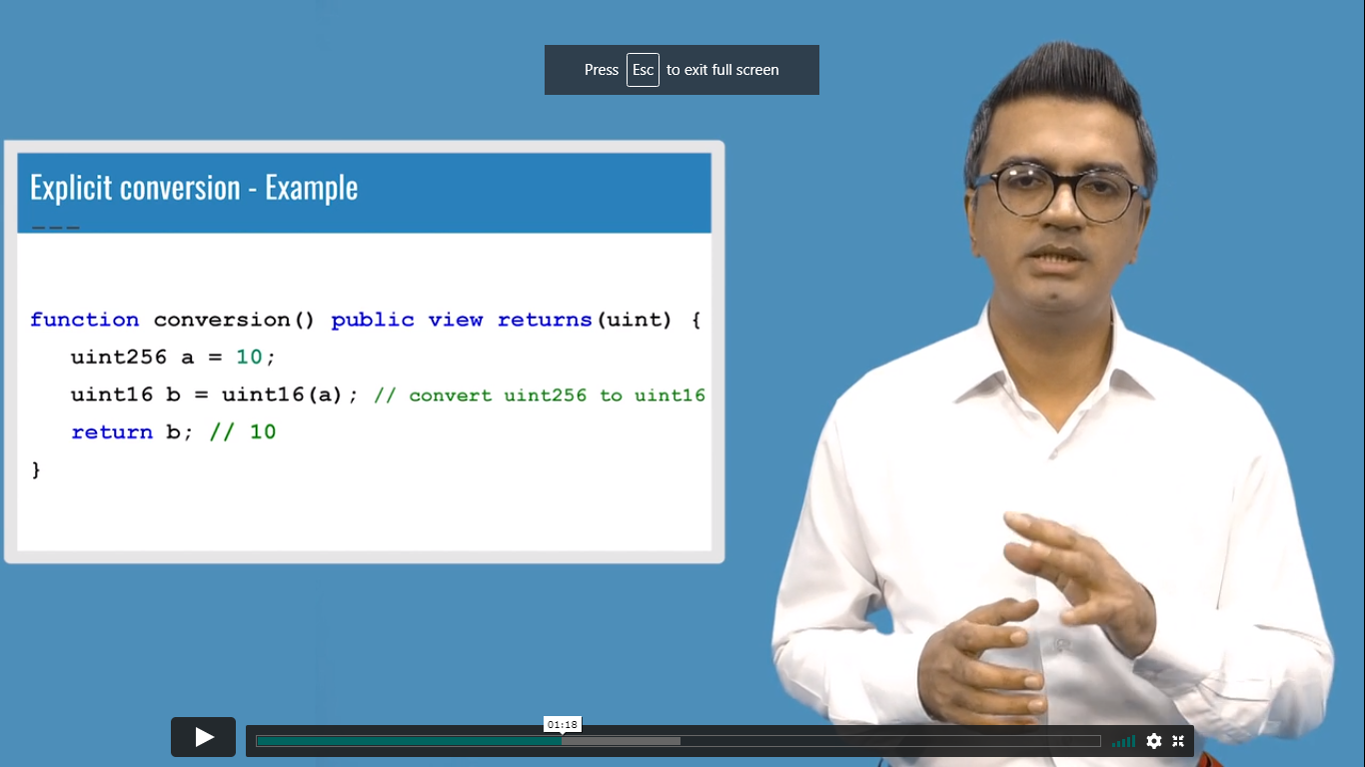

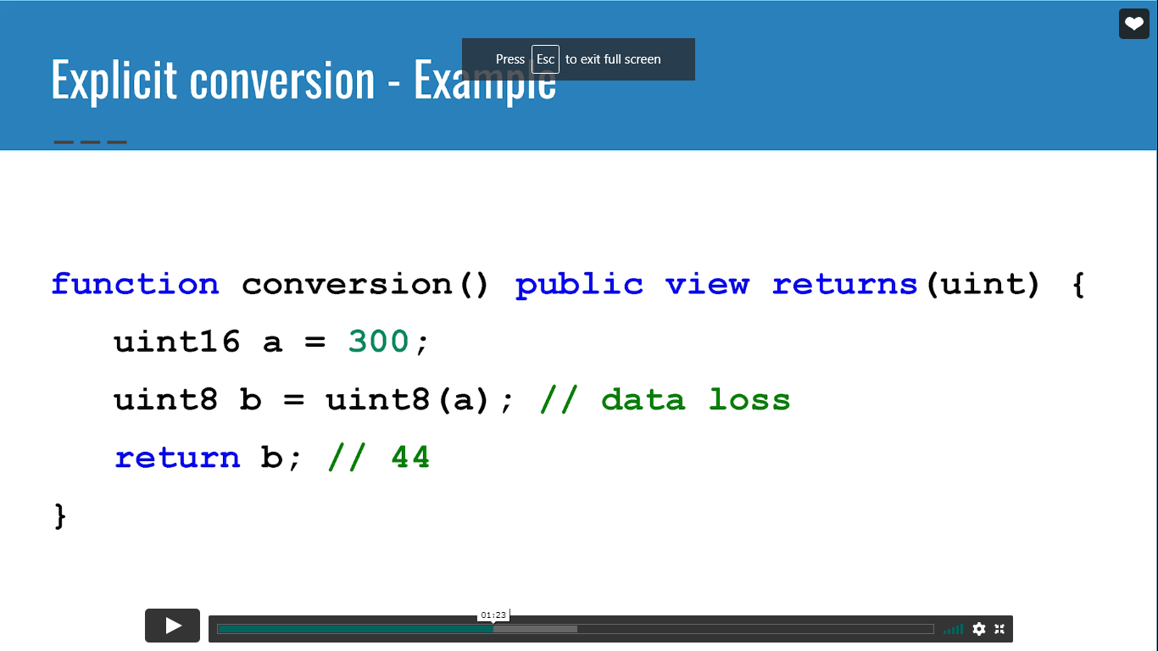

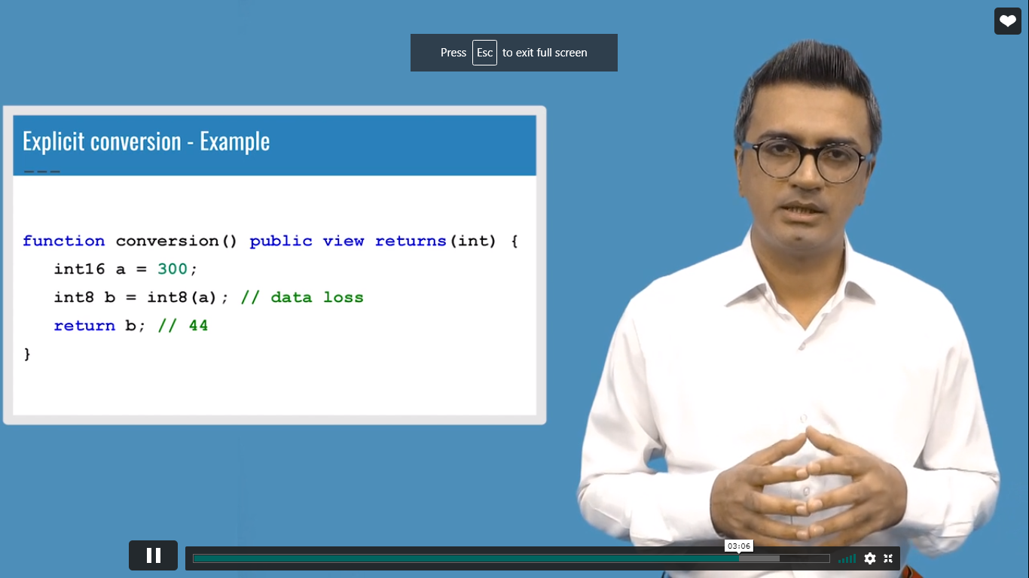

If data is lost it will return the available bits value

⇒ **Solidity return enum value in uint**

⇒ String to bytes conversion

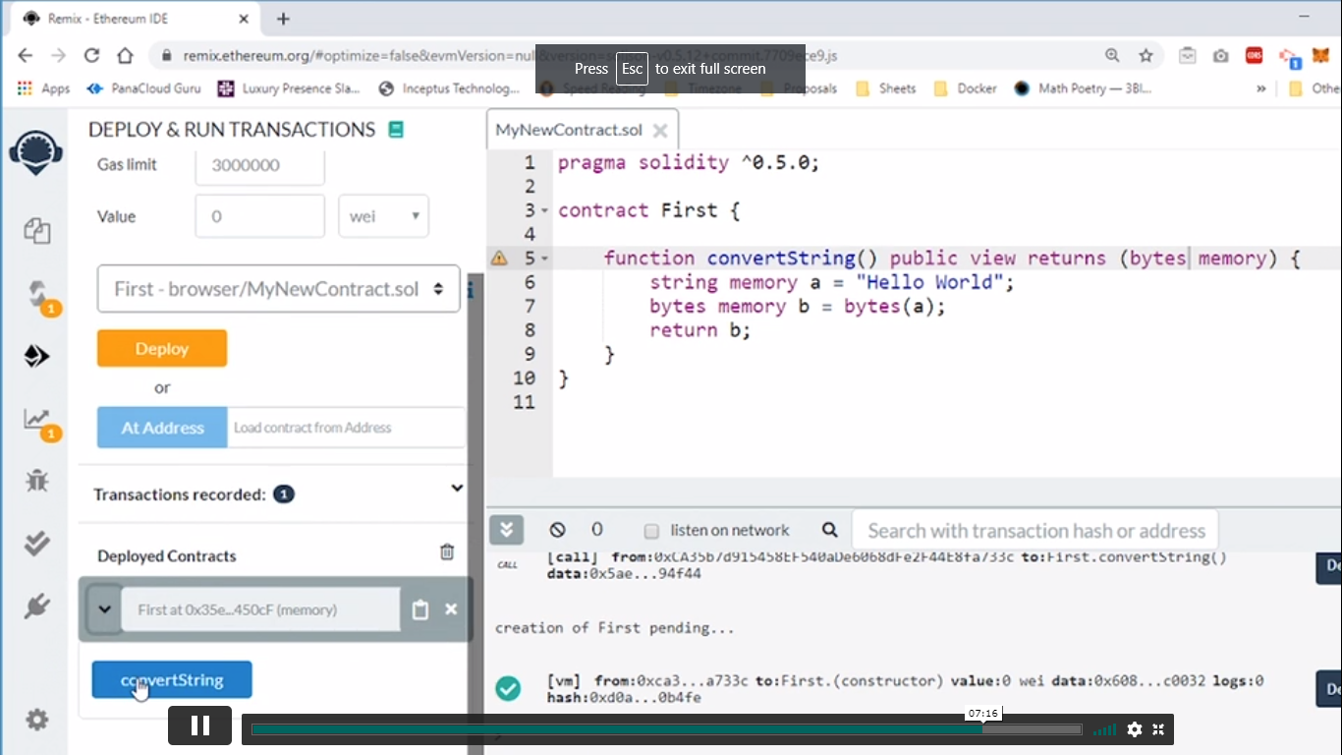

**Block Global Variables and Transaction:**

⇒ contract has do not directly access to the ledger

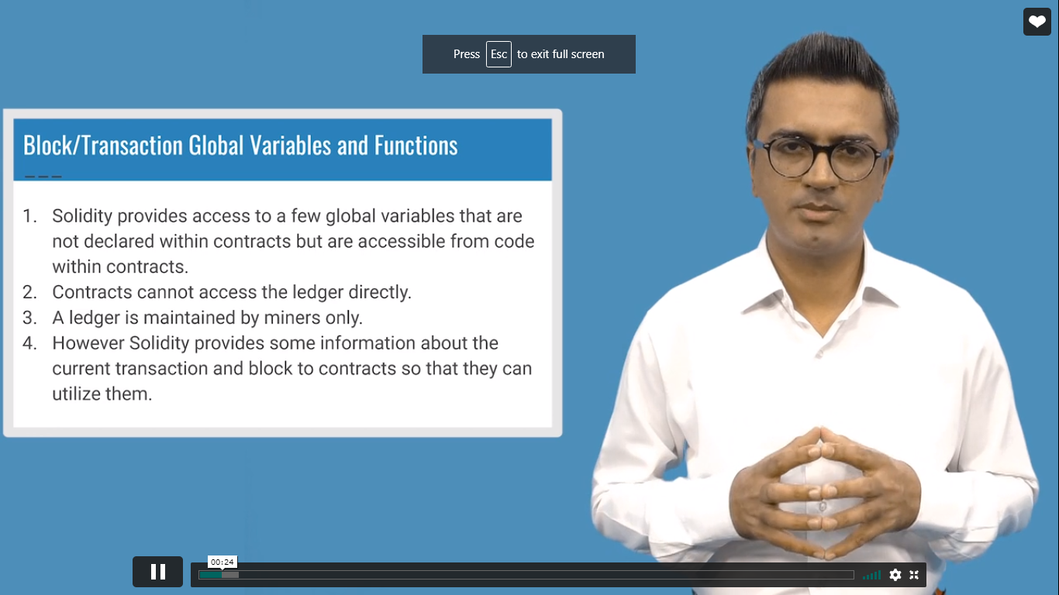

List of Global Variables:

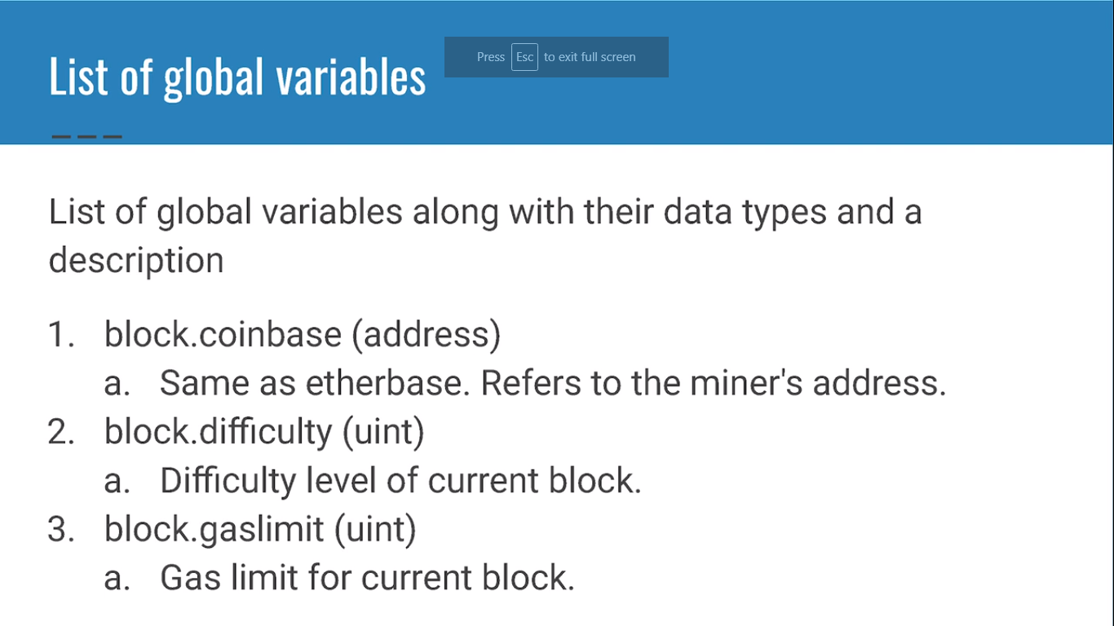

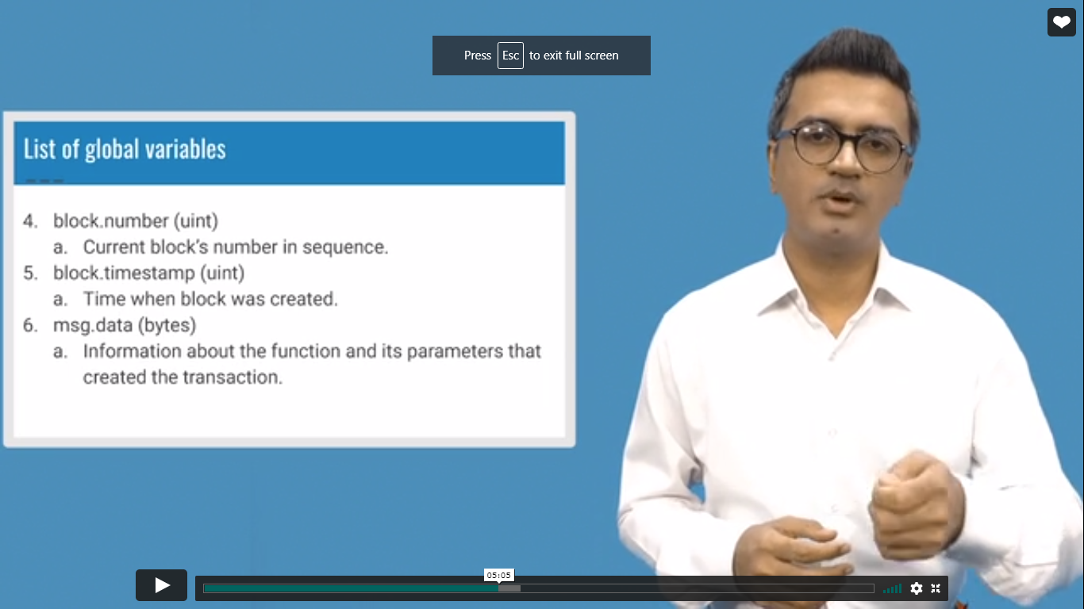

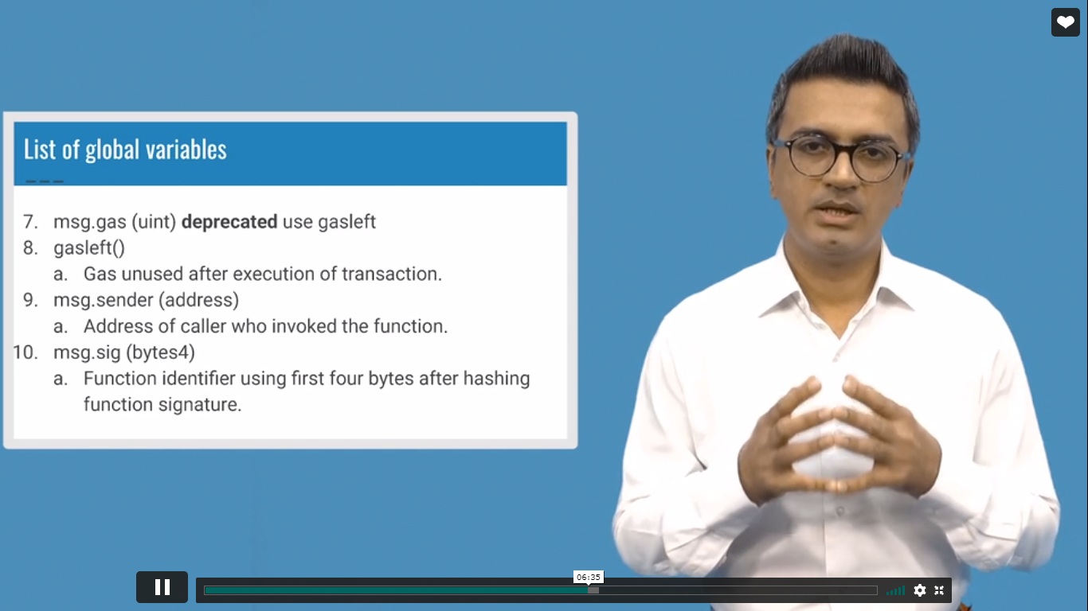

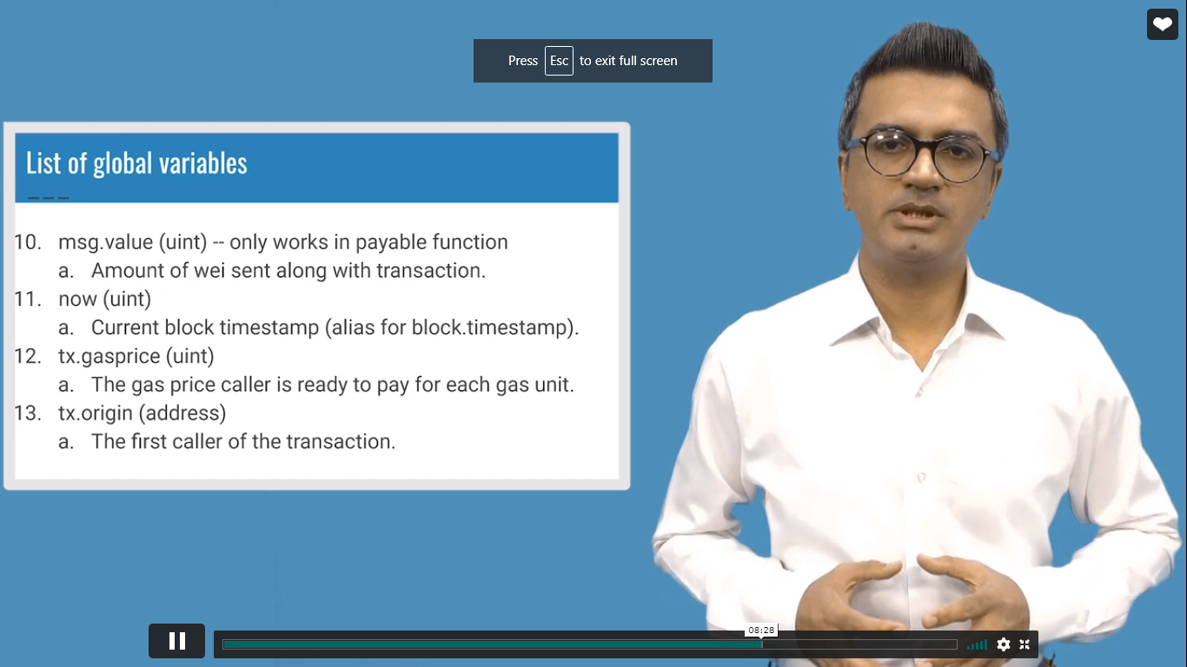

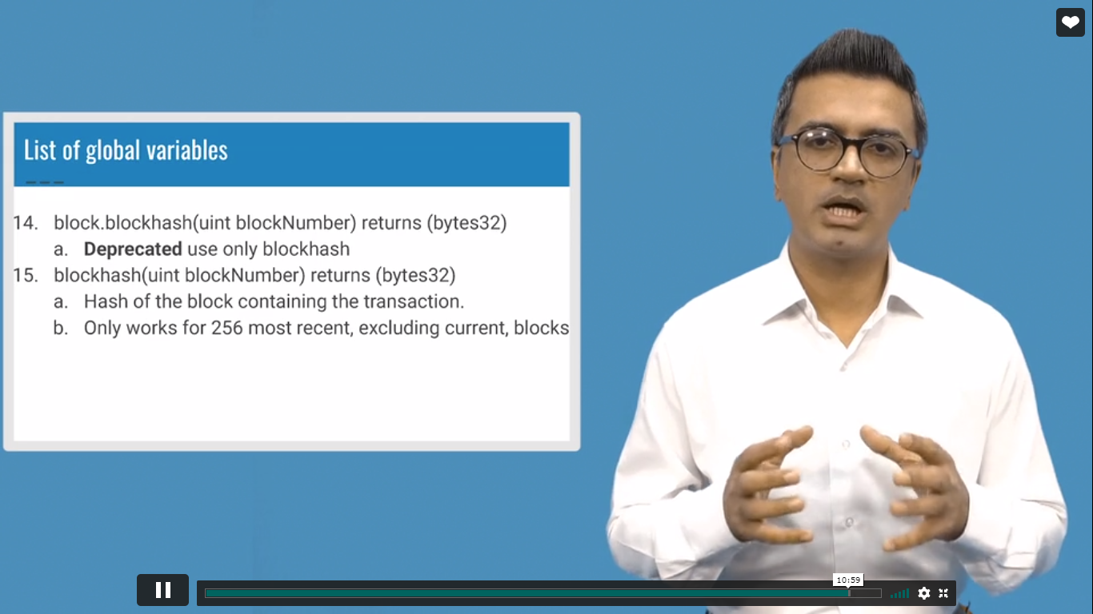

**Difference between tx.origin and msg.sender**

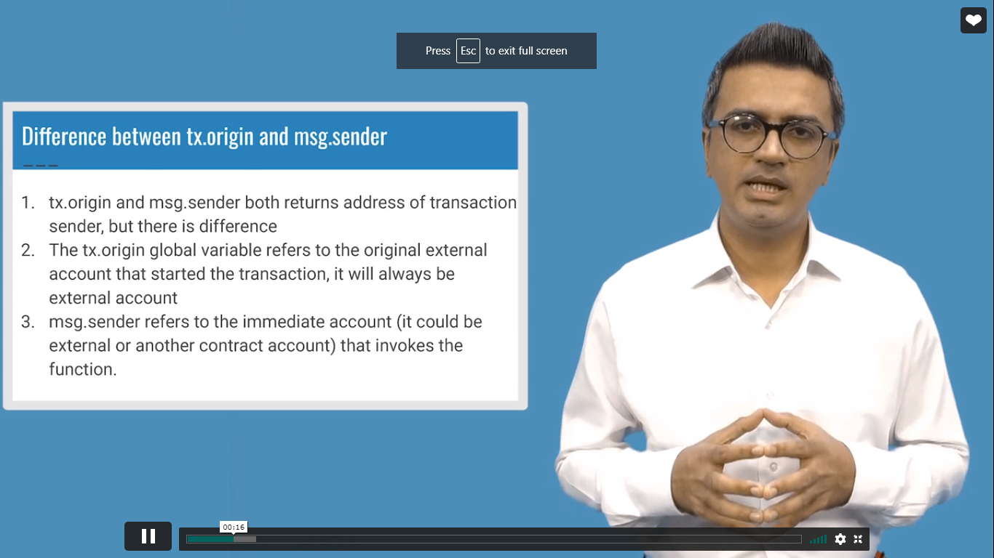

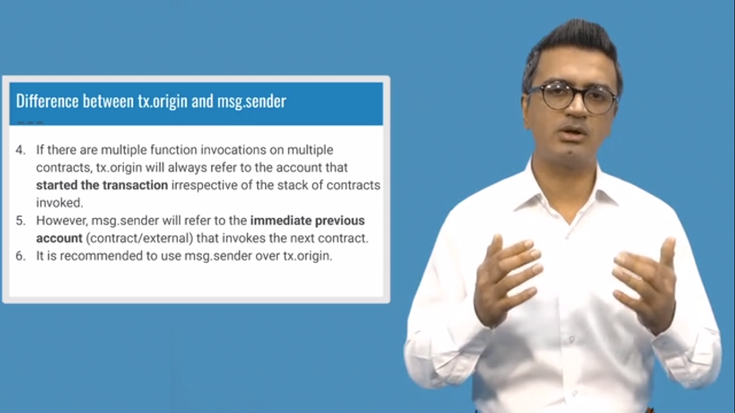

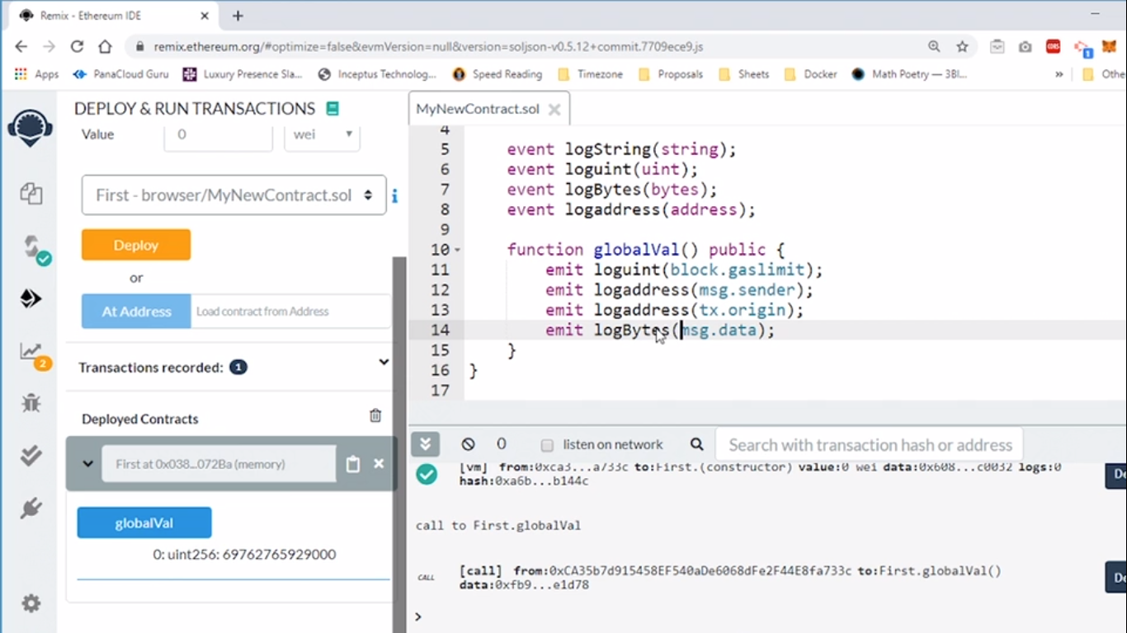

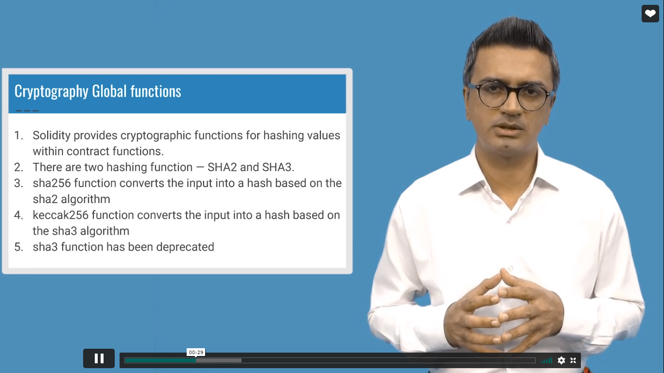

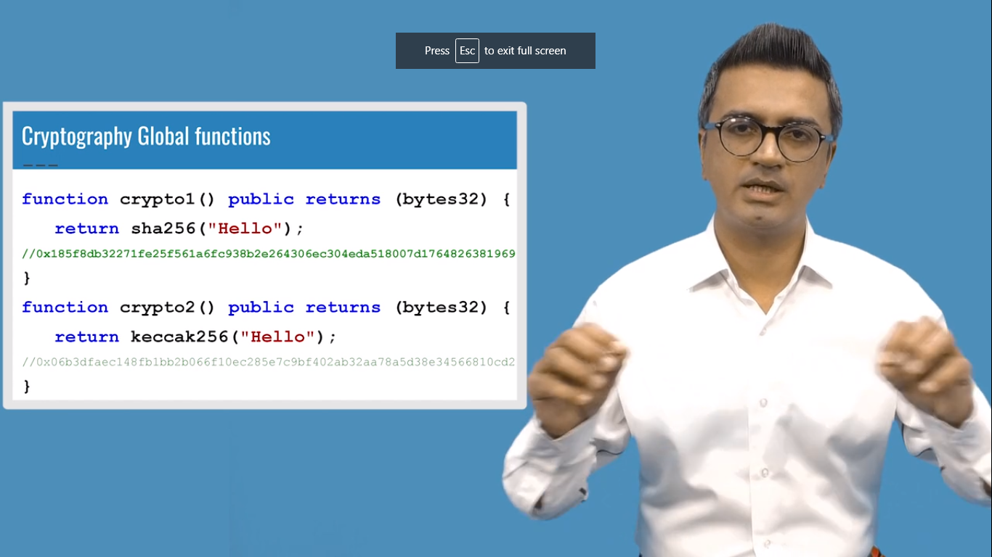

**Contract Global Variables:**

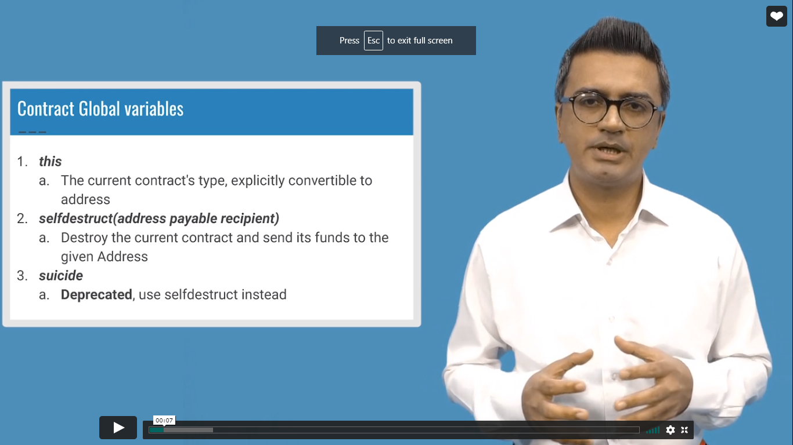

**contract MyBalance {**

**function getEther() public payable{}**

**function getValue() public returns(string memory){**

**return 'contract is working';**

**}**

**function removeContract() public {**

**selfdestruct(0x4B20993Bc481177ec7E8f571ceCaE8A9e22C02db);**

//address to send the ether

**}**

**}**